# Serve or Sponsor

Please put in the offering plate during any church service. Make a check out to your church, subject line Hope 4 Kids.

Name:

Address:

Phone #:

Email:

One Time Donation: $

* Your gift will be included in your year-end tax statement from the church

I wish to volunteer!

* Please email H4K about packing and volunteer opportunities

**Hope 4 Kids Contact Information:**

Please send an email to:

hope4kids.foodpacks@gmail.com

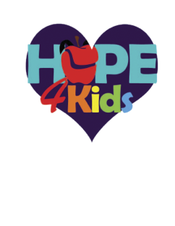We will respond in a couple of days.

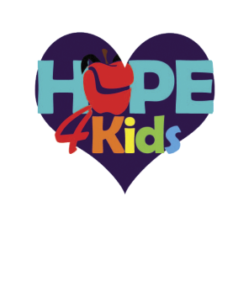

**In 2017, Allison Weber stated in a report for *Feeding America* that, “In America, 1 in 6 children struggles with hunger,…Kids at risk of hunger may be less equipped to reach their full potential as they engage with the world around them. Studies show that children from homes that lack consistent access to food are more likely to experience developmental impairments in areas like language, motor skills, and behavior.”**

What are some examples of food included in a pack?

The food packs will vary from week to week. Menus are planned in advance, to ensure they are not too heavy for the children to carry home. The packs provide breakfast and lunch at home during the weekend, which are typically the two meals children receive at school each week.

Fruit cups, cereal, snack bars, pretzels, raisins, canned tuna, and Ramen noodles are just a few of the items you might find in a pack on any given week. Additional food is added for holiday weekends.

***a weekend food program***

Providing a nutritious pack of food to support area students each weekend.

A Joint Mission Of:

Fairview Chapel

Mt. Carmel United Methodist Church

New Market United Methodist Church

# About Us

Hope 4 Kids is a weekend food program that started in 2012. It provides a weekend package of food to children in our community. School staff identify the needs of these children. Every week, a pack of food is sent home with the child to ensure they have a consistent source of nutrition on days they do not receive school meals.

During the 2023-24 school year,

Hope 4 Kids served approximately

111 students each week.

Those schools served are:

* Deer Crossing Elementary School
* New Market Elementary School
* New Market Middle School
* Oakdale Elementary School
* Oakdale Middle School
* Blue Heron Elementary School

What do the schools provide?

Each school selects the students to receive food packs, communicates with parents, protects the identity of families receiving assistance, and distributes the packs each week.

# SERVE

The Hope 4 Kids volunteers manage donations, plan menus, shop for food, pack the packs, and deliver packs to the school each week. Packings occur usually once each month at New Market UMC during the school year. We invite you to join us on any packing date. Hope 4 Kids is an opportunity for volunteers of all ages to work side by side in ministry.

# Packing for 2024-2025 school year:

**All packings held at**

**New Market UMC**

5501 Old New Market Rd

PO Box 111 (for mailing)

New Market, MD, 21774

The second Tuesday of each month at 6:00pm in the yellow Schoolhouse east of the church.

# Sponsor

Sponsor a child for the year

It costs approximately $150.00 a year to feed an individual student for 38 weekends. Every donation makes an impact, and all amounts are greatly appreciated. If you feel called to support Hope 4 Kids, please complete the attached donation form and include it with your donation. Make checks payable to Mt. Carmel with Hope 4 Kids on the subject line and mail to Mt. Carmel UMC, 9411 Baltimore Road, Frederick, MD 21704

